ASSIGNMENT-14.1
HT NO:2303A51910
Batch No: 28
Course:AI Assisted Coding
Task 1 : Portfolio Website Design
You are building a personal portfolio website to showcase your
work.
Requirements:
• Create sections for About Me, Projects, and Contact.
• Use AI to:
o Suggest color palettes and typography.
o Create a responsive layout with Grid/Flexbox.
o Add smooth scrolling navigation.
Prompt:
Generate a complete single-file HTML code for a personal portfolio website that I can run in VS Code.
Requirements:
- Sections: About Me, Projects, Contact
- Use CSS Flexbox or Grid for layout
- Suggest a modern color palette and typography
- Add a navigation bar with smooth scrolling between sections
- Keep HTML, CSS, and JavaScript in the same file
- The code should be clean and easy for beginners
Code:
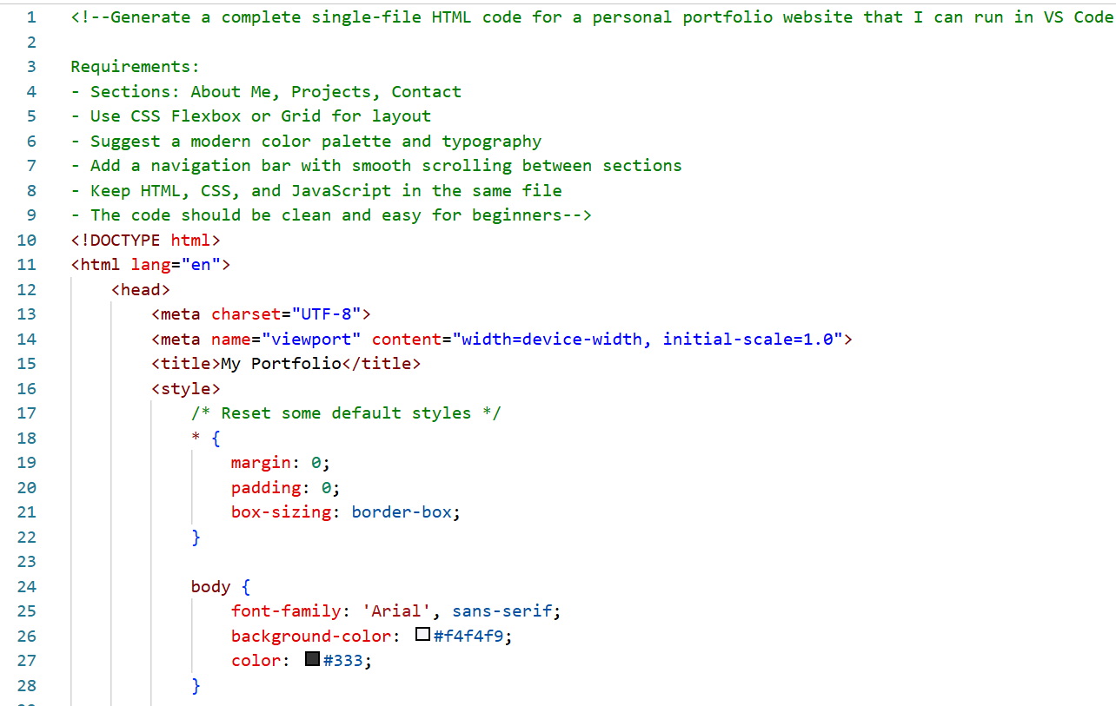
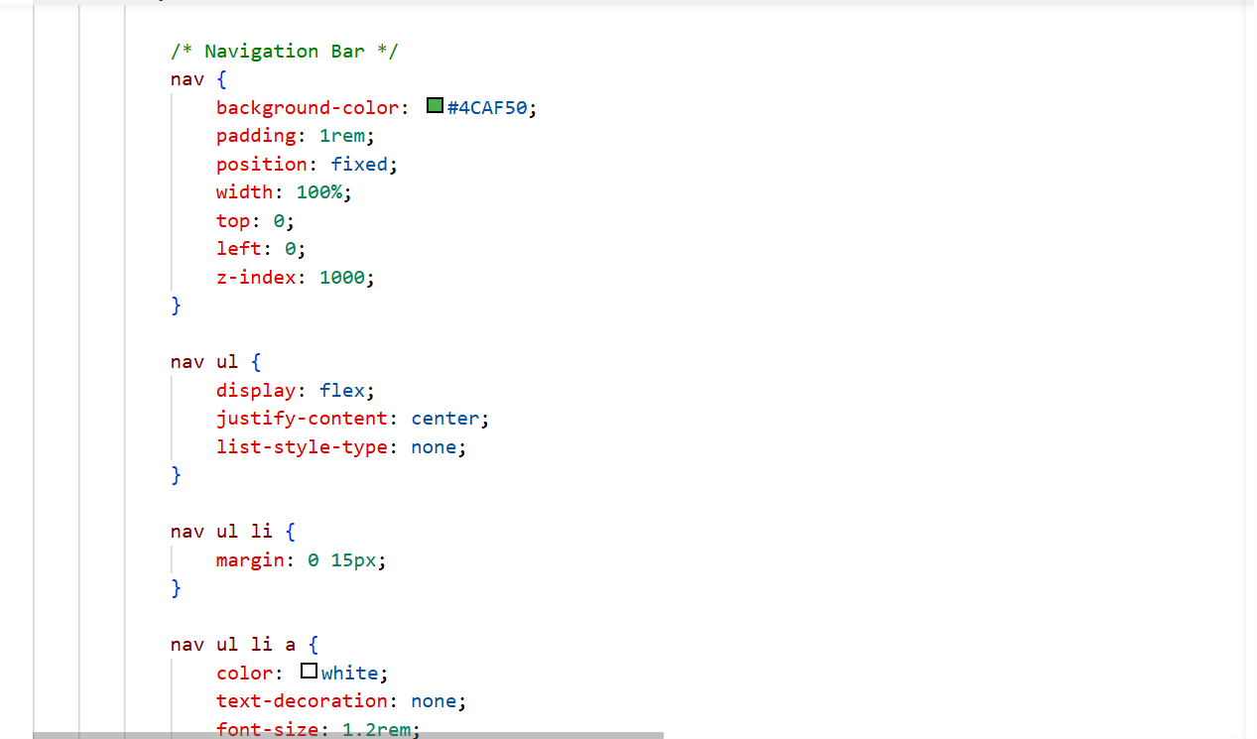
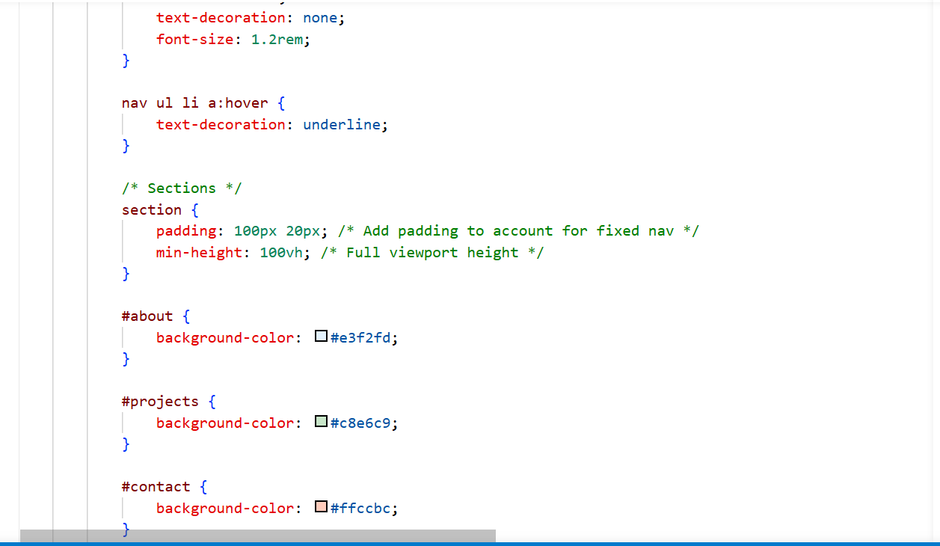
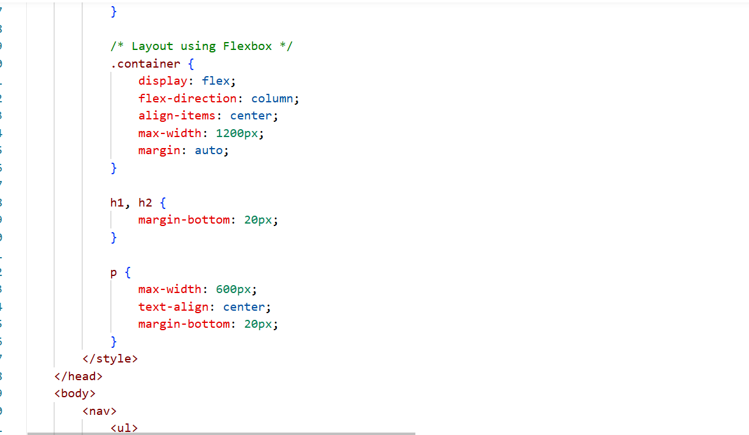
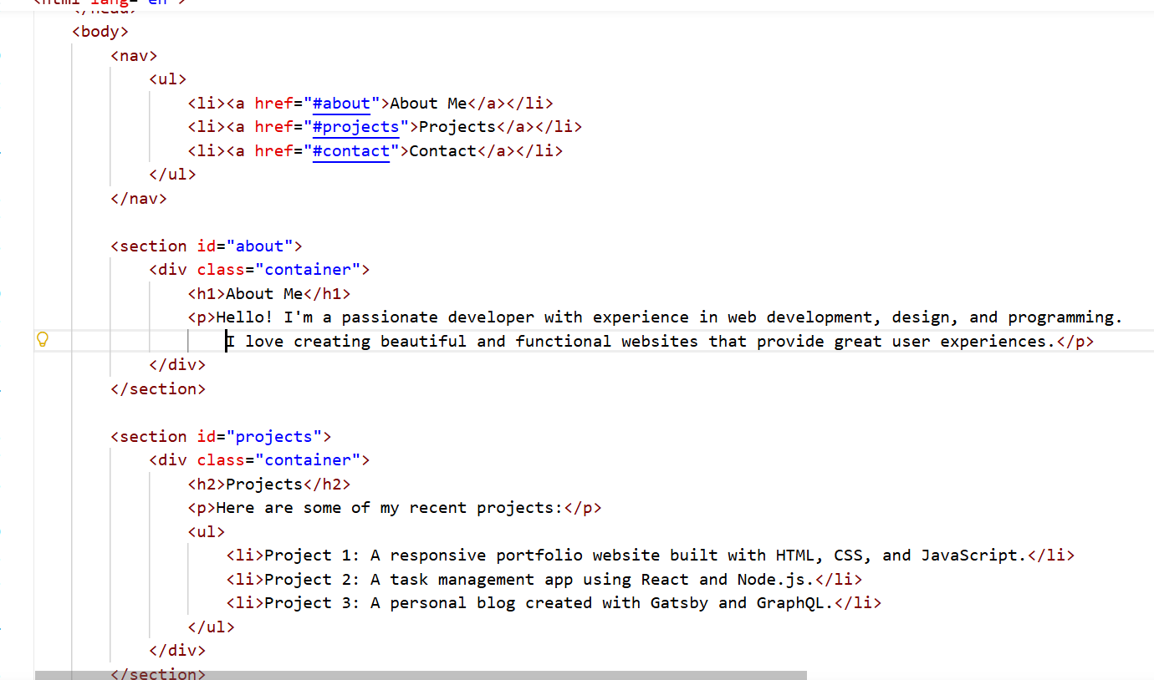
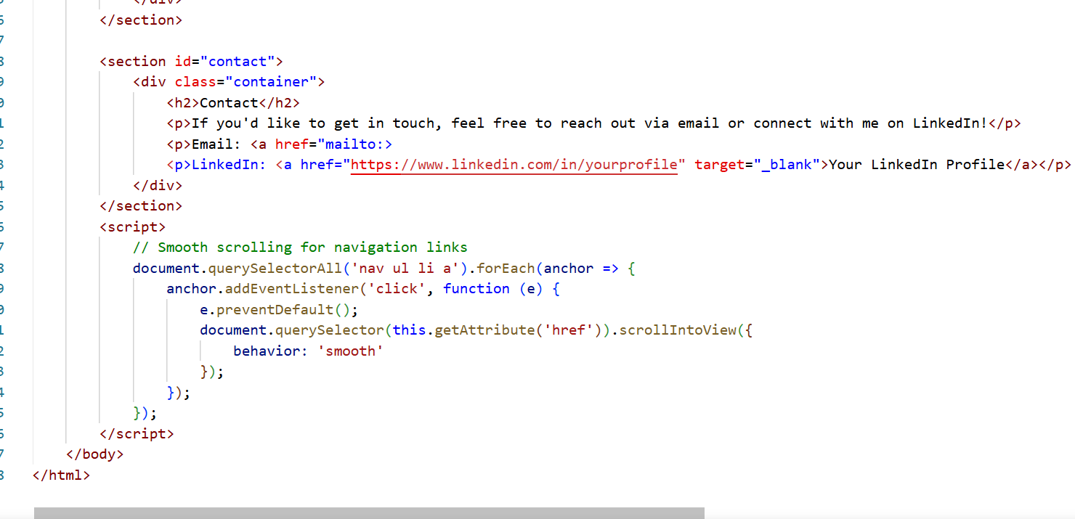
Output:
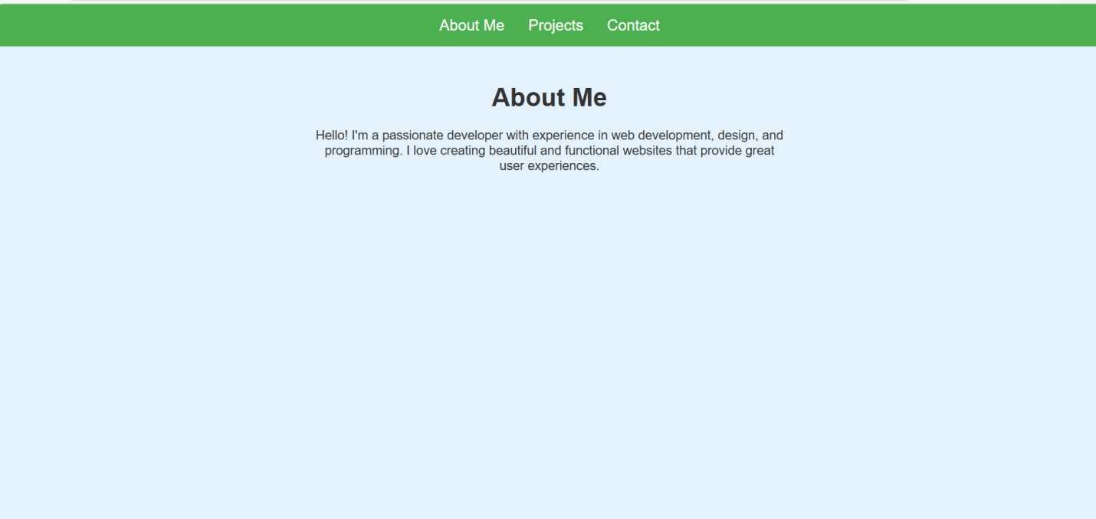
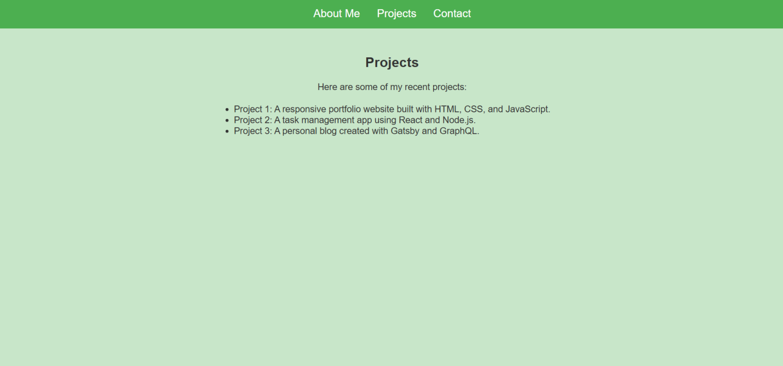
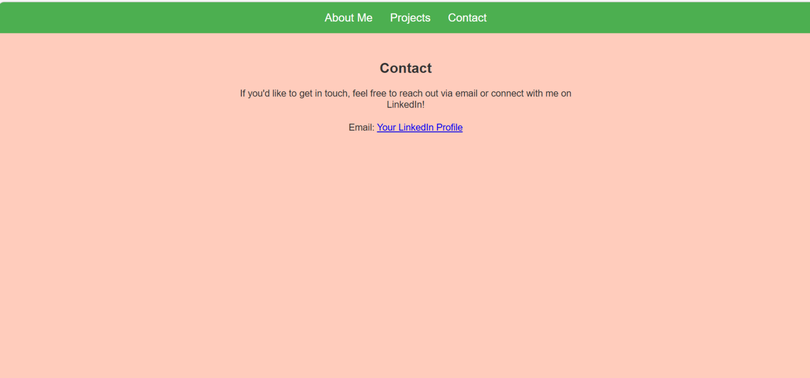
Justification:
1. The portfolio website helps showcase personal skills, projects, and contact details in a structured way.
2. Separate sections like About, Projects, and Contact improve organization and readability.
3. Using Flexbox or Grid creates a responsive layout that adapts to different screen sizes.
4. A consistent color palette and typography improve visual appeal and professionalism.
5. Smooth scrolling navigation enhances user experience.
6. Overall, the design makes the portfolio easy to navigate and visually attractive.

Task 2 :Online Store Product Page
Design a product display page for an online store.
Requirements:
• Display product image, title, price, and "Add to Cart" button.
• Use AI to:
o Style with BEM methodology.
o Make layout responsive.
o Add hover effects and "Add to Cart" alert.
Prompt:
Generate a single HTML file for a responsive online store product page that can run in VS Code.
Requirements:
- Display product image, title, price, and an "Add to Cart" button
- Use BEM naming methodology in CSS classes
- Add hover effects on the product card and button
- When the "Add to Cart" button is clicked, show a JavaScript alert
- Include HTML, CSS, and JavaScript in the same file
Code:
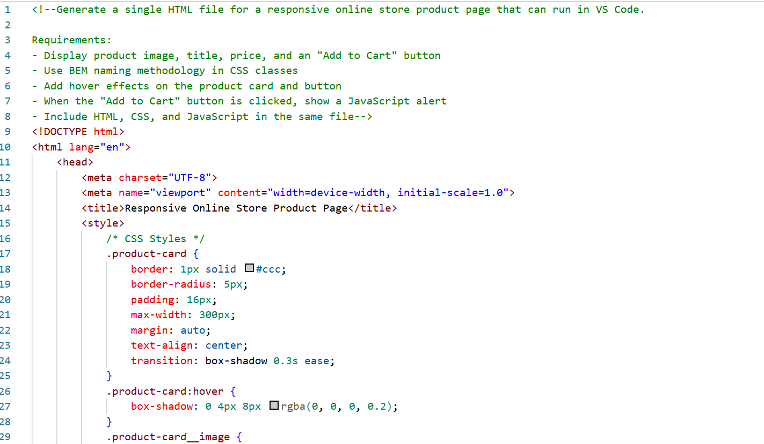
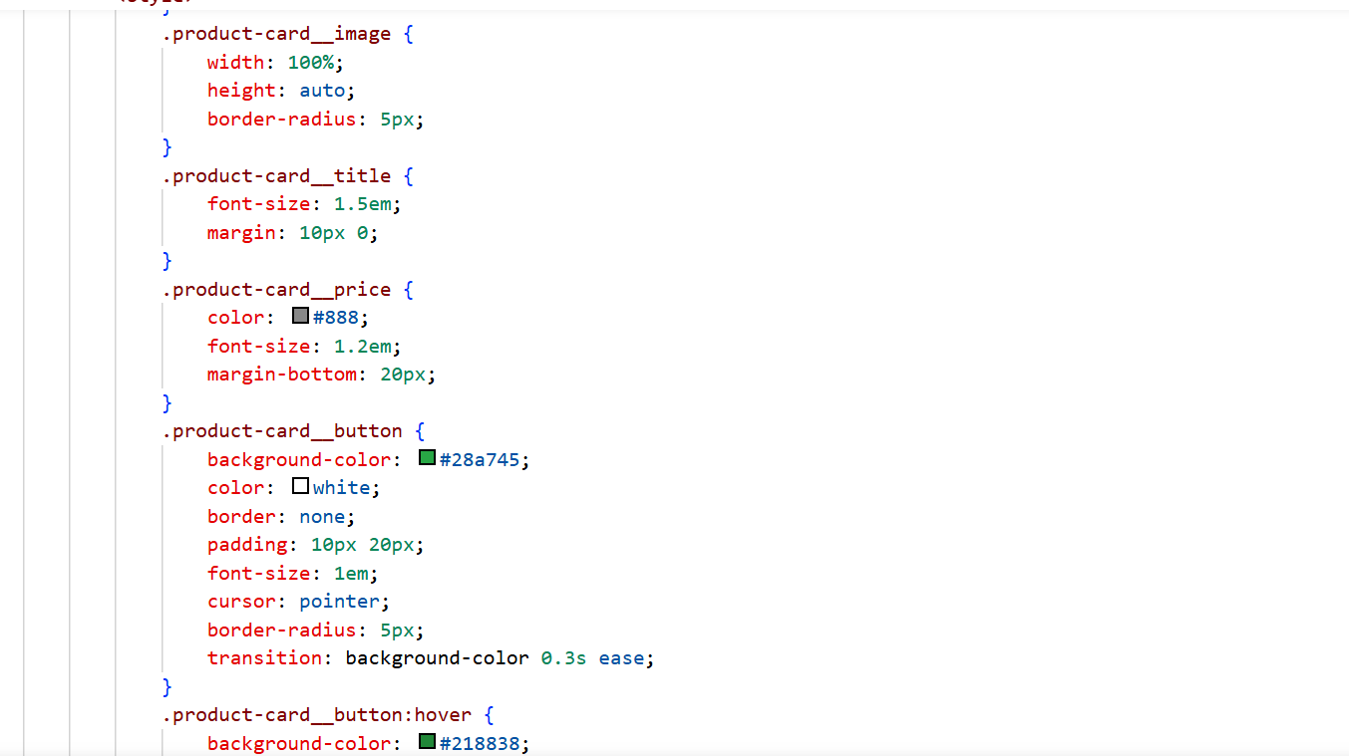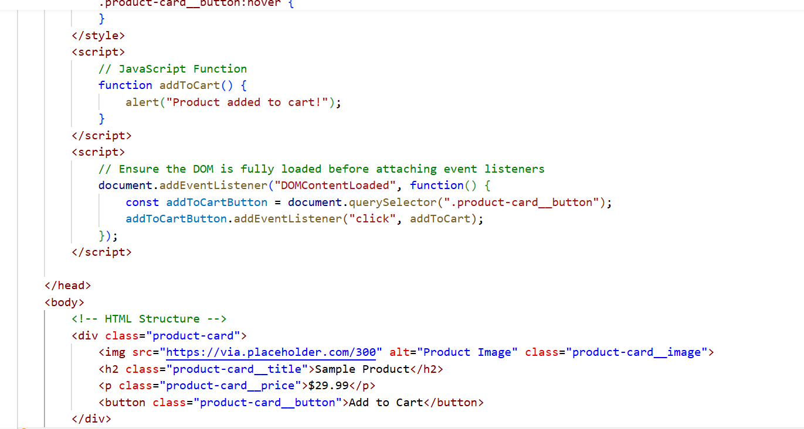
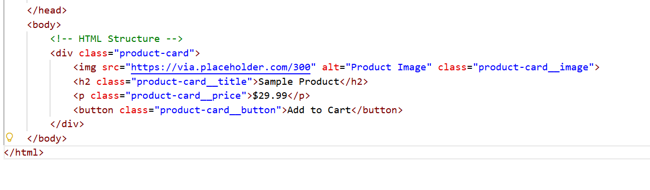
Output:
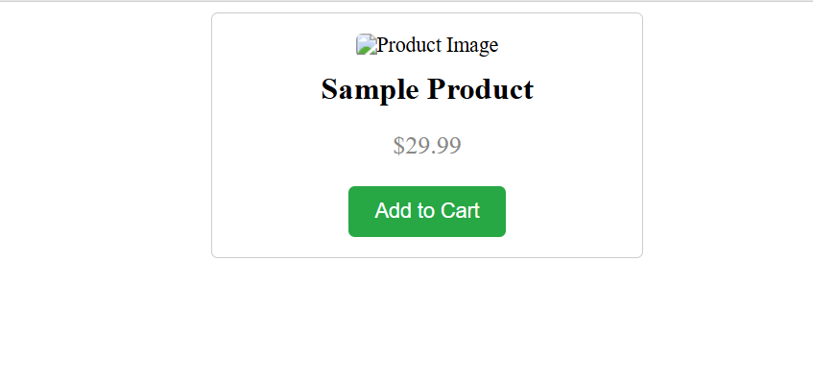
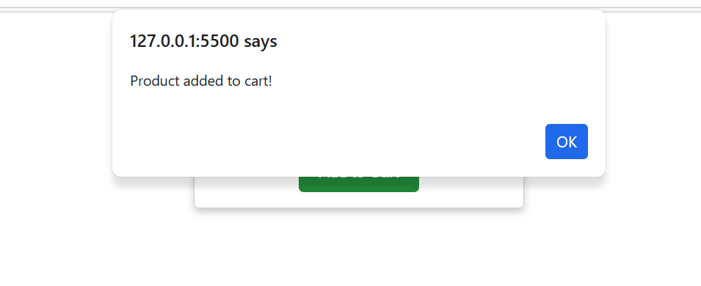
Justification:
1. The product page displays essential product information such as image, title, and price.
2. The "Add to Cart" button allows basic interaction for users.
3. Using BEM methodology improves CSS structure and maintainability.
4. Responsive design ensures the page works on both mobile and desktop devices.
5. Hover effects provide visual feedback when users interact with elements.
6. The alert message confirms that the product has been added to the cart.

Task 3 :Event Registration Form
Build an event registration form for a conference.
Requirements:
• Collect name, email, phone number, and session selection.
• Use AI to:
o Add form validation with JavaScript.
o Make the form accessible with labels and ARIA.
o Style with a professional look
Prompt:
Generate a single HTML file for an event registration form that I can run in VS Code.
Requirements:
- Fields: Name, Email, Phone Number, Session Selection
- Add JavaScript form validation
- Use labels for accessibility and simple ARIA attributes
- Style the form with a professional design
- Include HTML, CSS, and JavaScript in one file
Code:
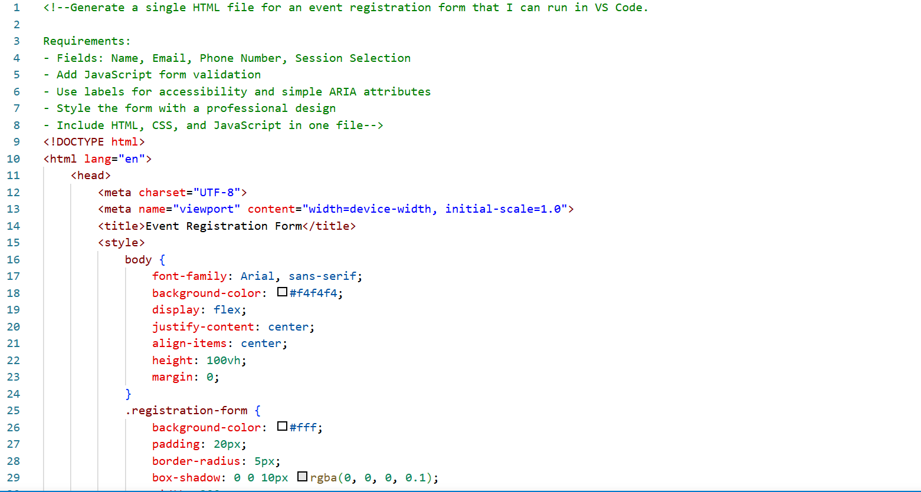
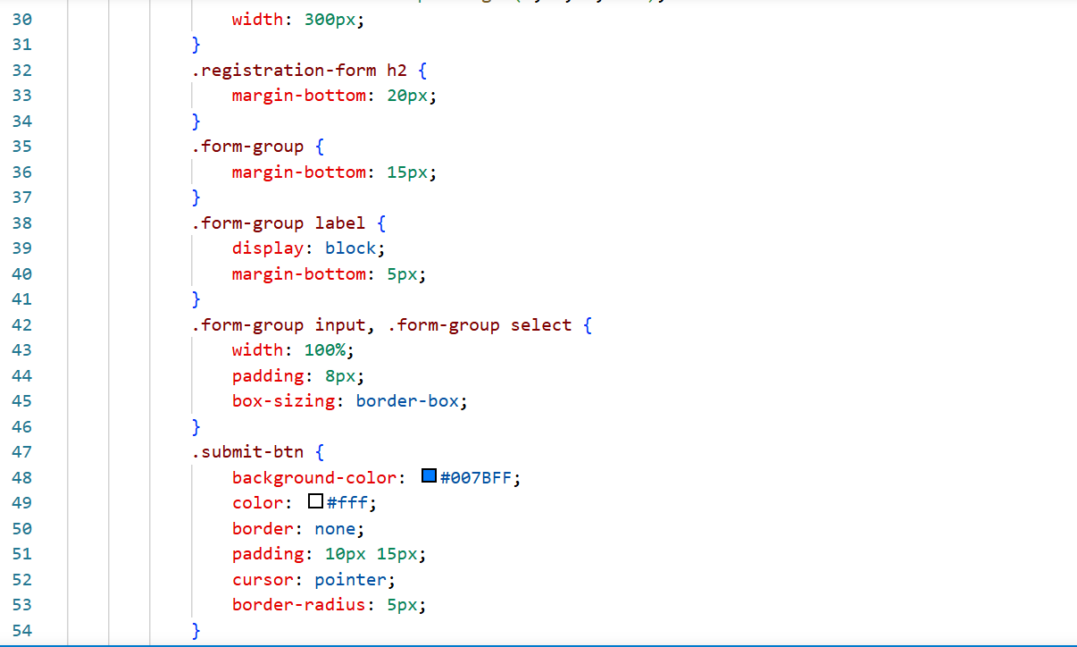
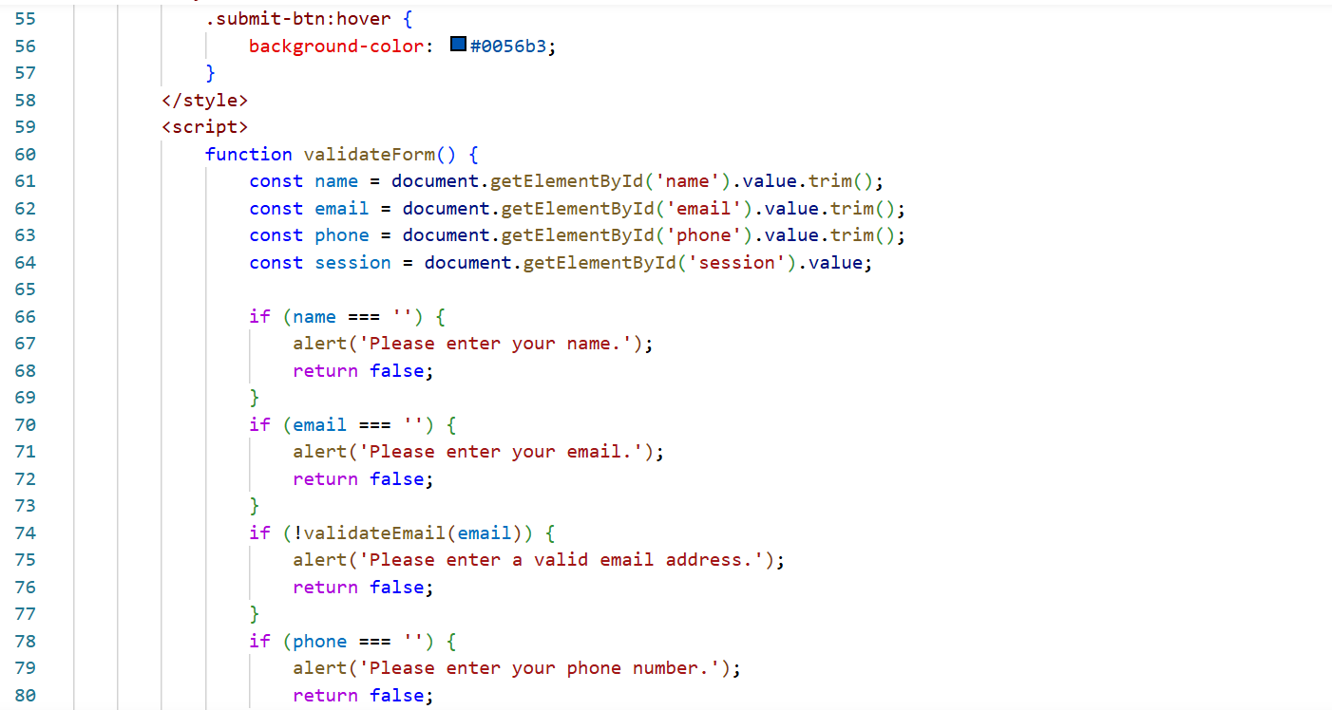
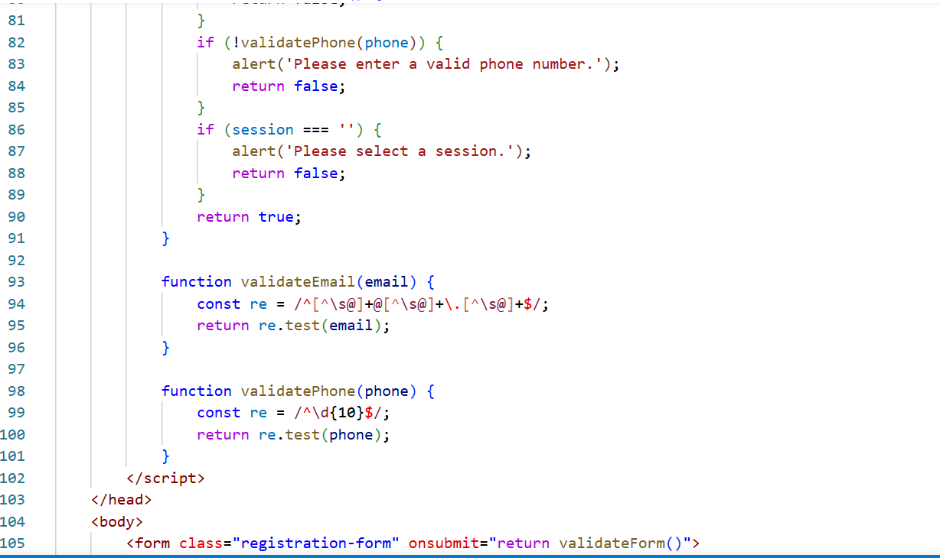
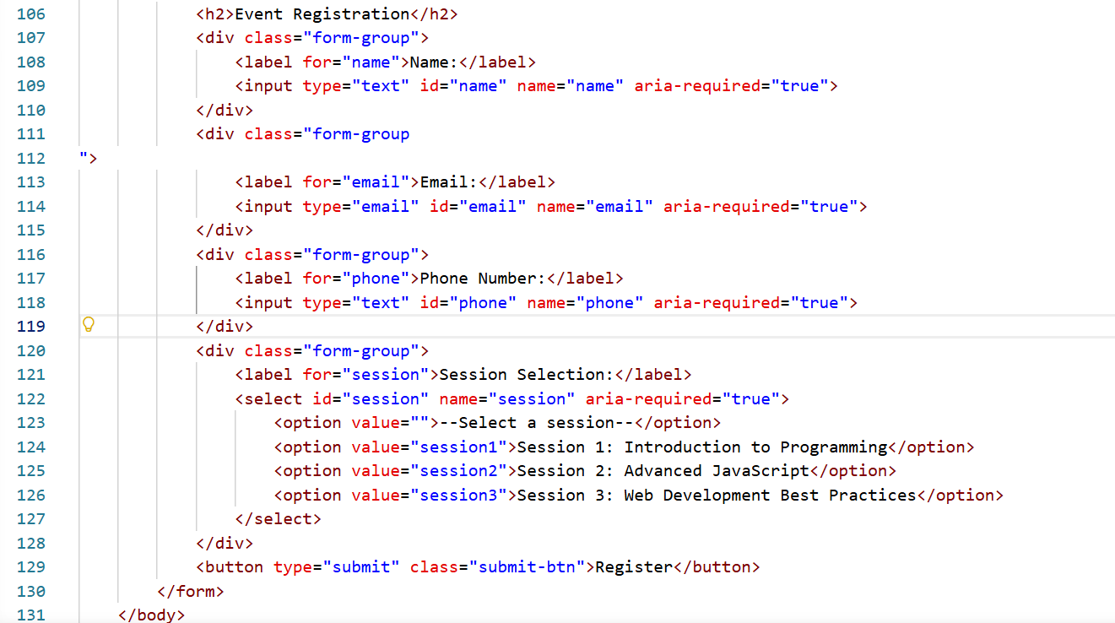
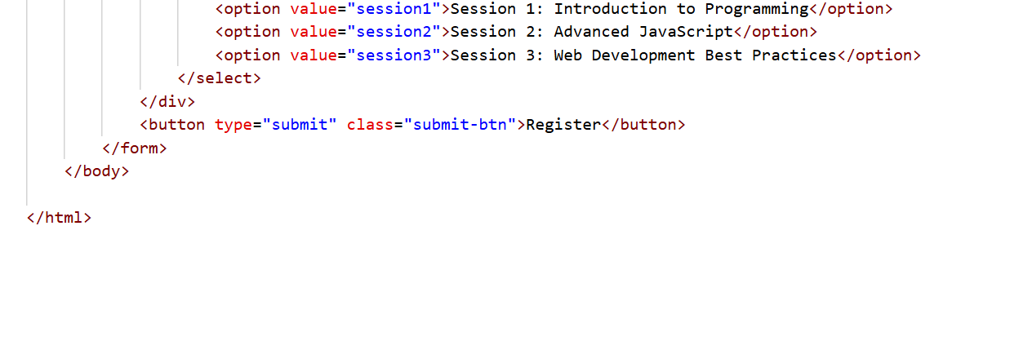
Output:
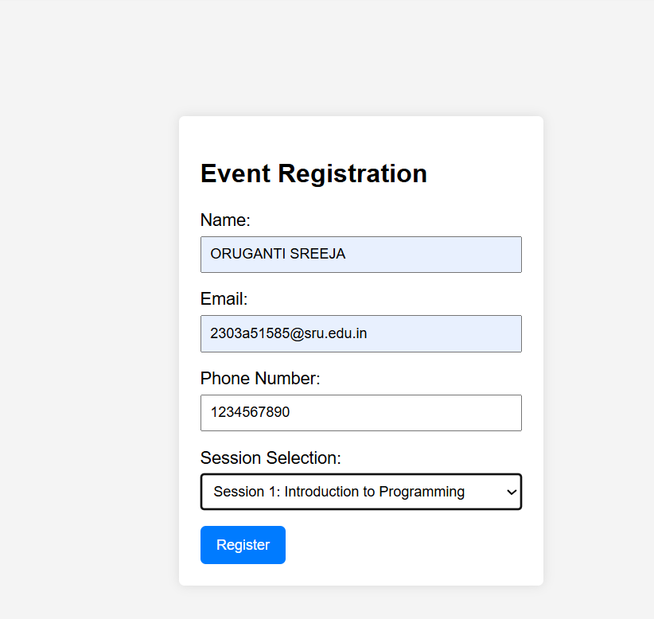
Justification:
1. The registration form collects important participant details for an event.
2. Fields like name, email, phone number, and session help organize attendee information.
3. JavaScript validation ensures that users enter correct and required data.
4. Using labels and ARIA attributes improves accessibility for all users.
5. A clean and professional design makes the form easy to use.
6. This improves both usability and data accuracy.

Task 4 : Resume Website
Build a one-page online resume.
Requirements:
• Sections: Profile Summary, Skills, Education, Experience.
• Use AI to:
o Propose professional typography styles.
o Align sections using CSS Grid.
o Add smooth scroll navigation between sections.
Prompt:
Generate a single HTML file for a one-page resume website that can run in VS Code.
Requirements:
- Sections: Profile Summary, Skills, Education, Experience
- Use professional typography
- Align sections using CSS Grid
- Add a navigation menu with smooth scrolling
- Include HTML, CSS, and JavaScript in the same file
Code:
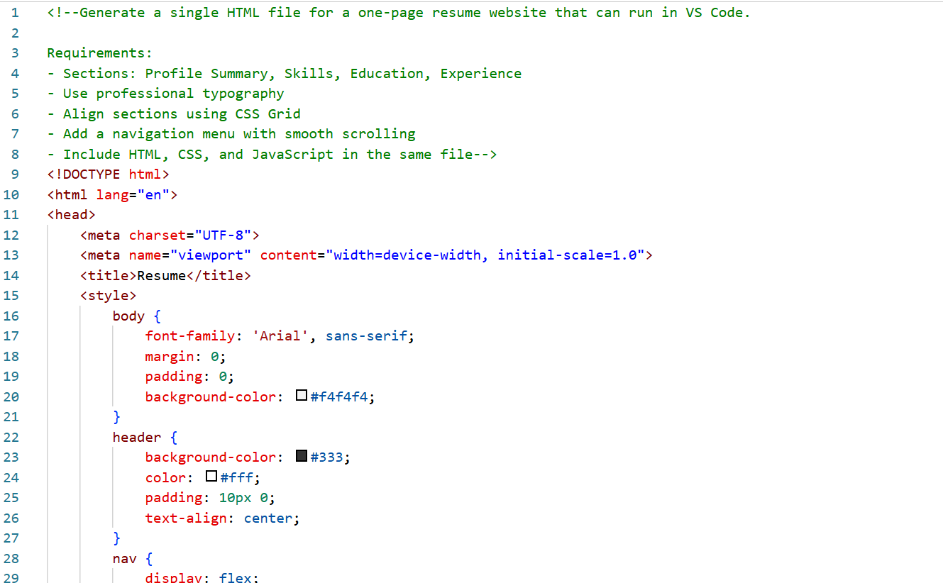
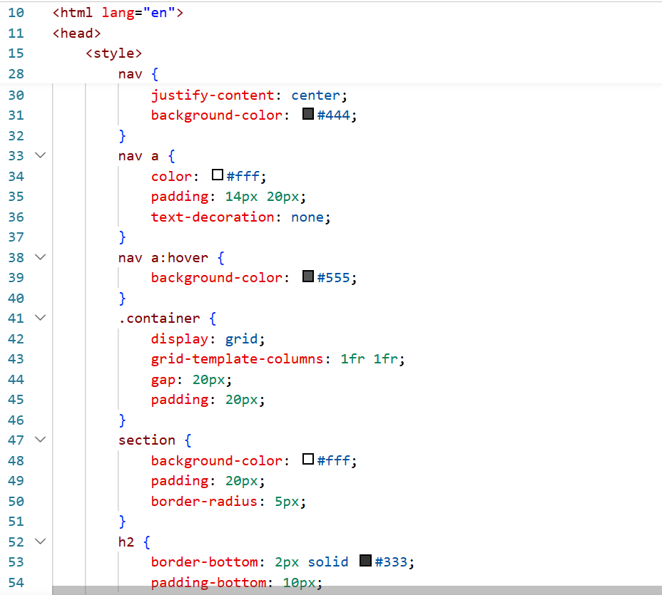
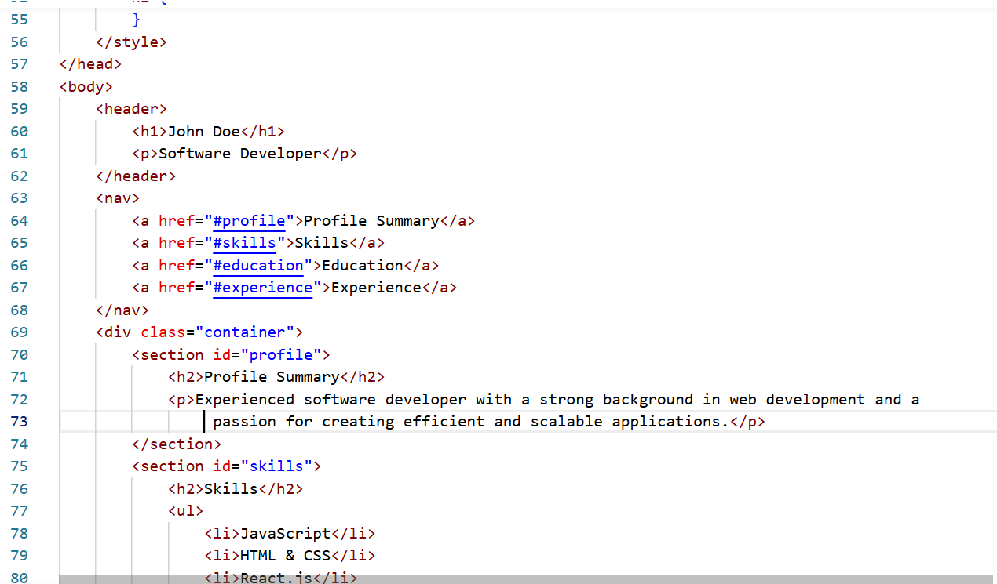
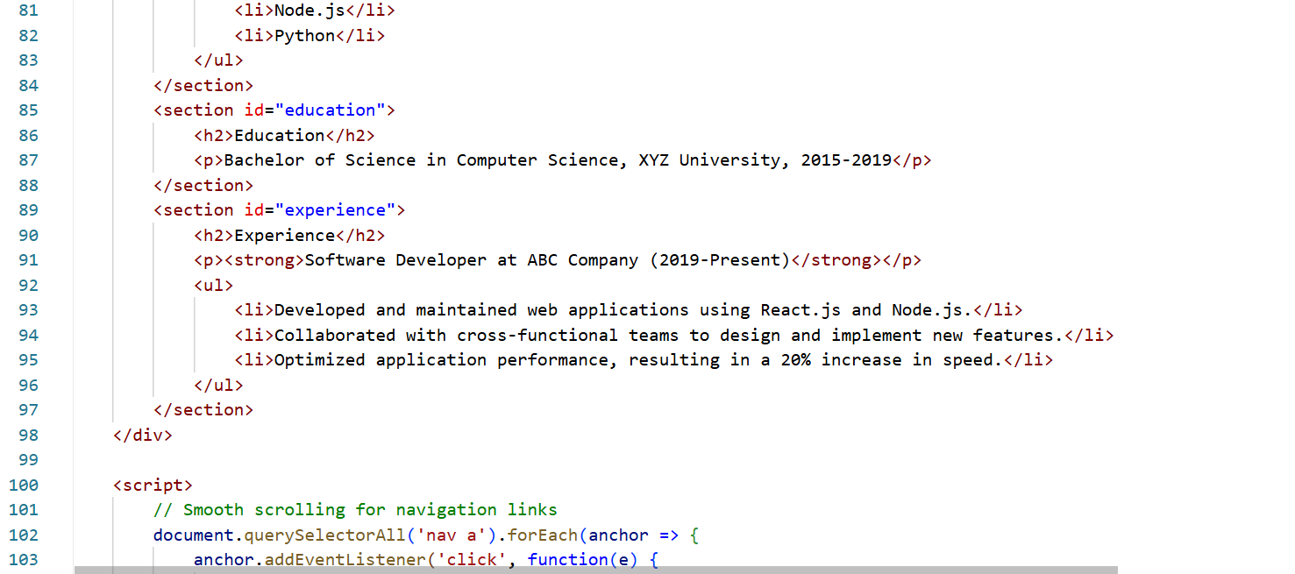
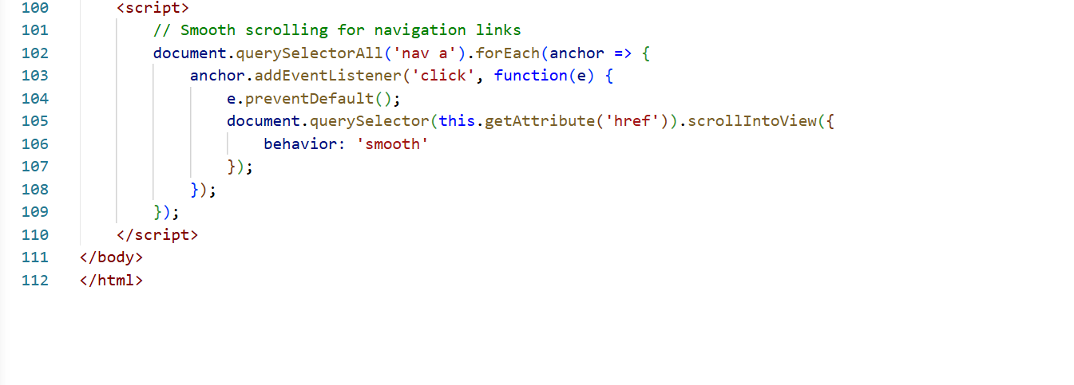
Output:
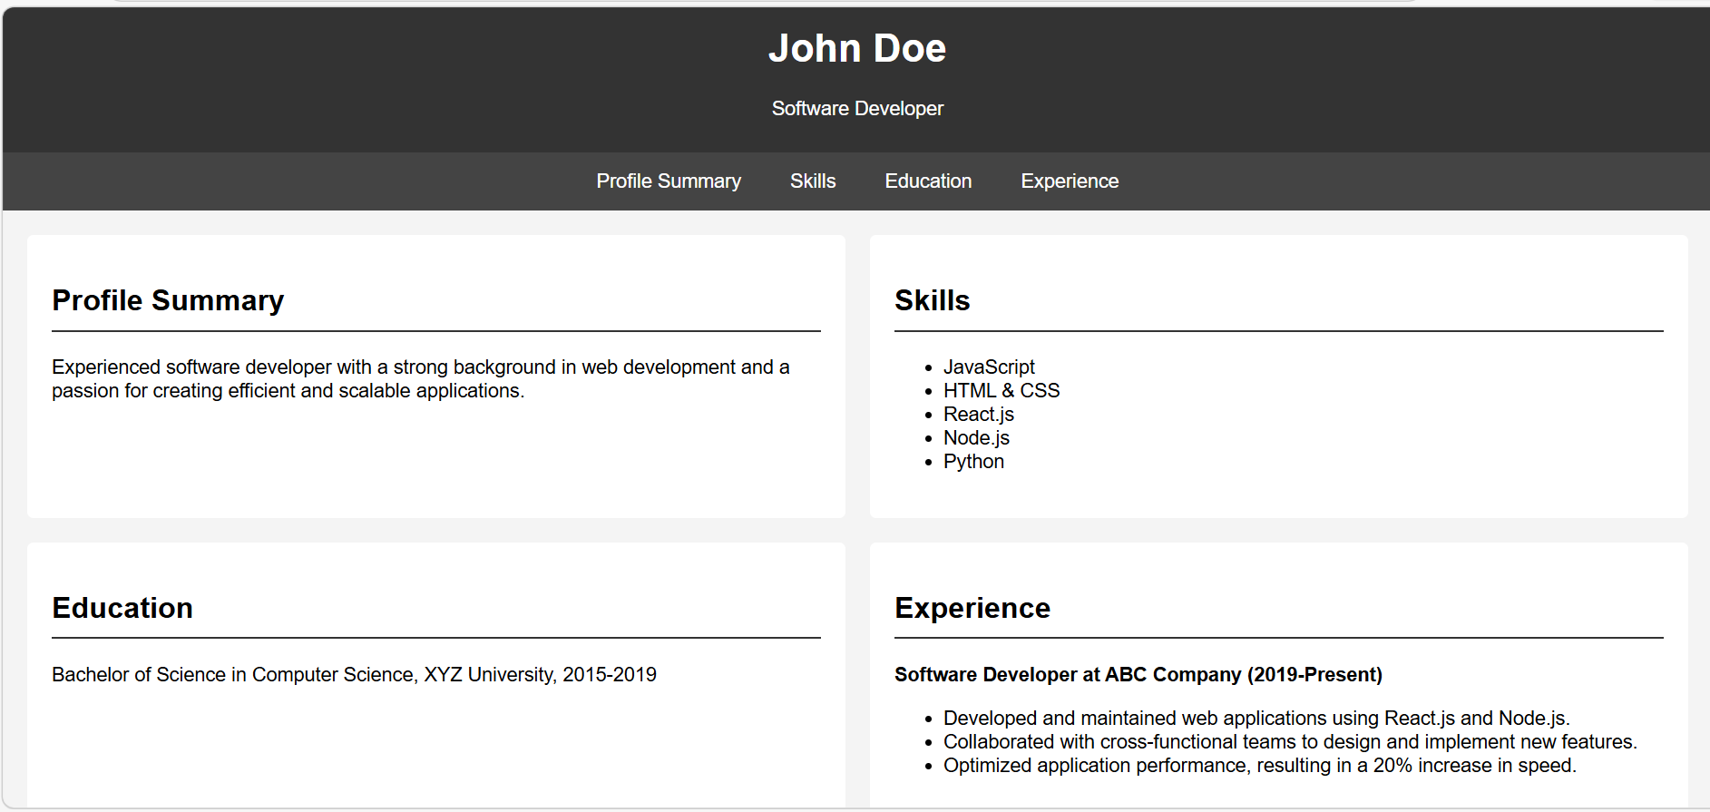
Justification:
1. The one-page resume website presents professional information in a structured format.
2. Sections like Profile, Skills, Education, and Experience help organize content clearly.
3. Professional typography improves readability and presentation.
4. CSS Grid helps align sections neatly across the page.
5. Smooth scrolling navigation allows users to quickly move between sections.
6. This format creates a modern and accessible online resume.

Task 5 : Restaurant Menu Page
Design a digital menu page for a restaurant.
Requirements:
• Display menu items with name, description, and price.
• Use AI to:
o Suggest a food-friendly color palette.
o Design a responsive card-based layout.
o Add hover effects on menu items.
Prompt:
Generate a single HTML file for a restaurant digital menu page that I can run in VS Code.
Requirements:
- Show menu items with name, description, and price
- Use a food-friendly color palette
- Design a responsive card-based layout
- Add hover effects to menu cards
- Include HTML and CSS in the same file
Code:
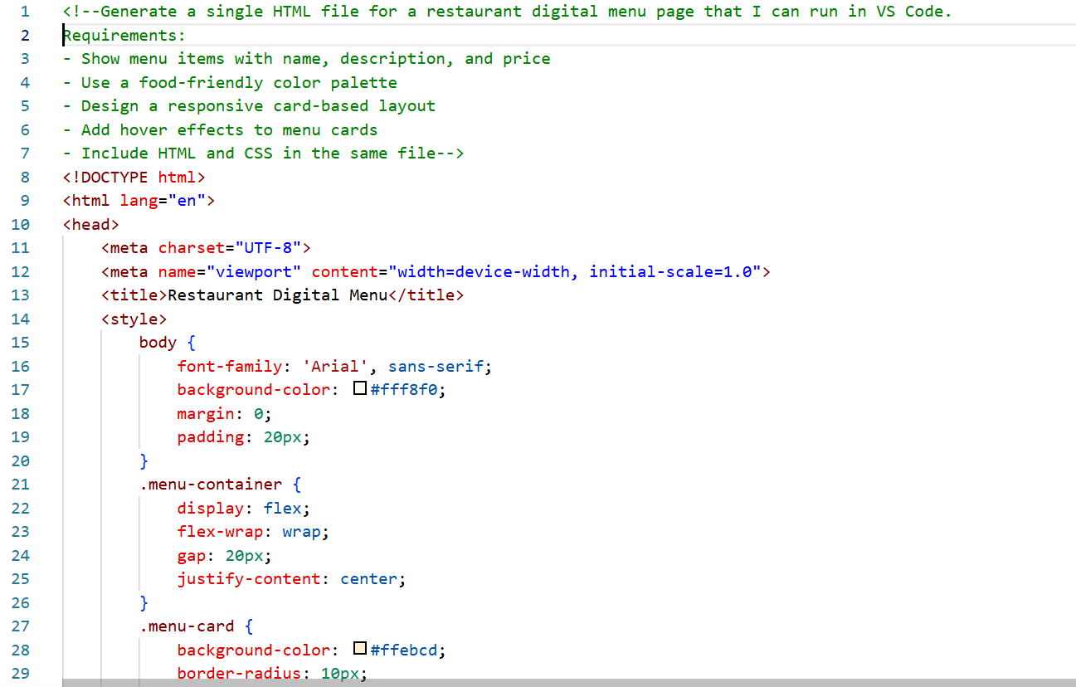
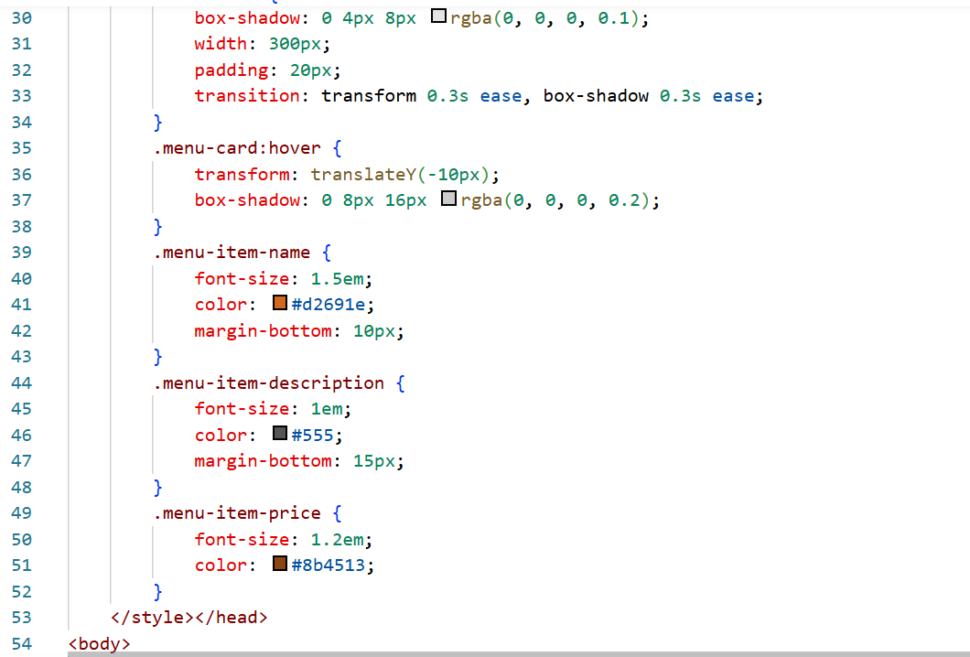
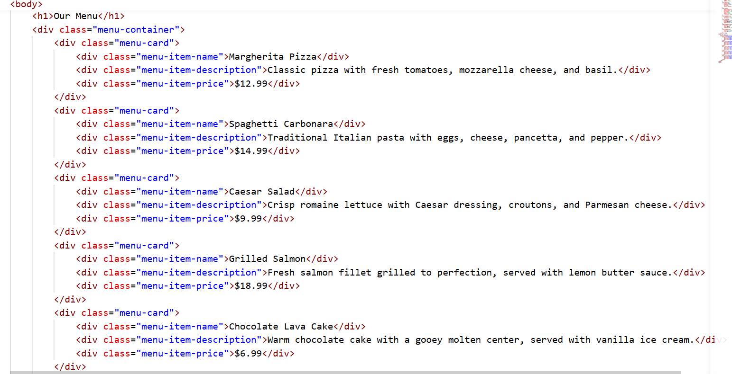
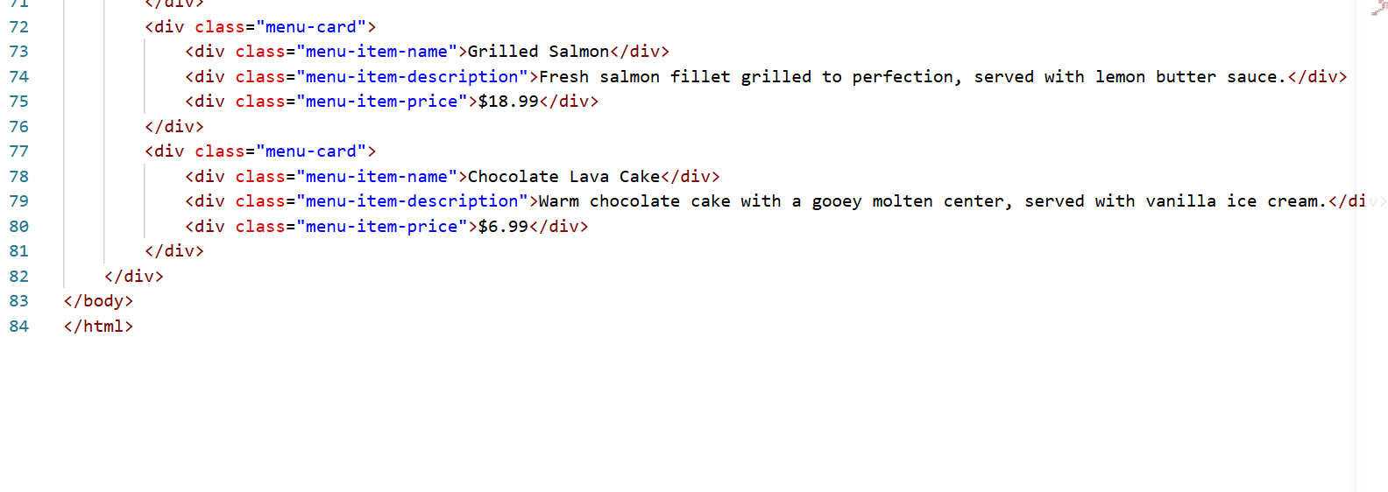Output:
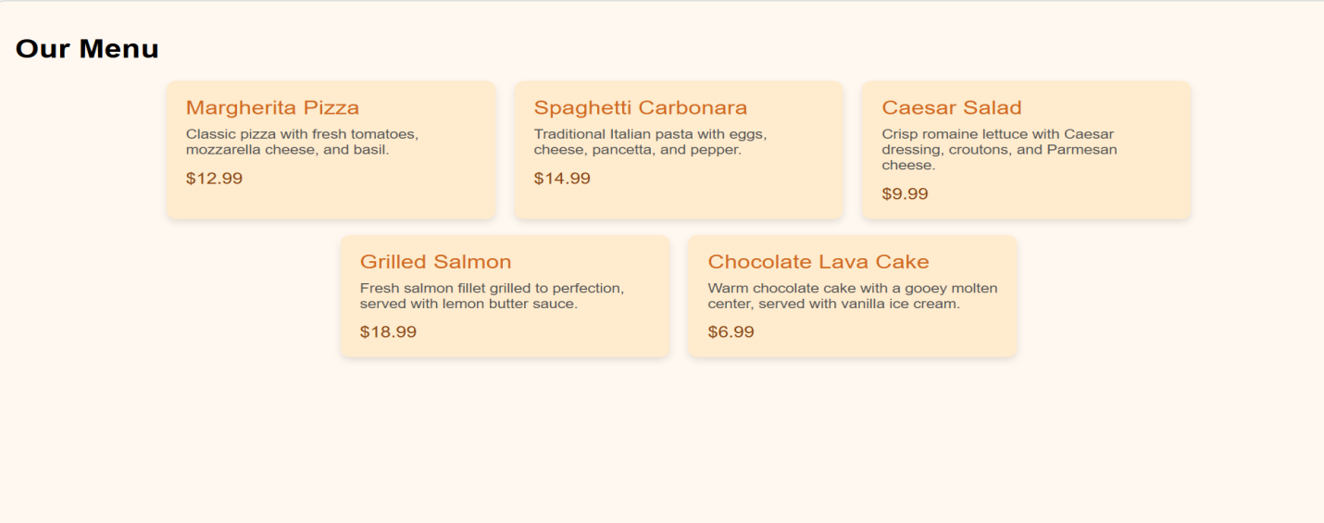
Justification:
1. The digital menu page allows restaurants to present menu items online.
2. Each item includes name, description, and price for clear information.
3. A food-friendly color palette enhances the visual appeal of the page.
4. Card-based layout organizes menu items neatly and improves readability.
5. Hover effects provide interactive feedback for users.
6. Responsive design ensures the menu works well on phones, tablets, and desktops

